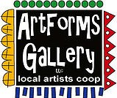
October 2019 Workshops
620 N. Broadway, Pittsburg, KS 620-240-0165

ArtForms Gallery is a co-op of 21 different artists offering monthly workshops ranging from oil painting, glass fusing, pottery, wood carving, metalsmithing, jewelry, textiles, kids’ art, photography, and more! All workshops are held at the Gallery unless otherwise noted. Please call ArtForms Gallery to register for any artist’s workshop. 620-240-0165

Refunds/Cancellations—Decisions regarding refunds and cancellations are determined by the artist leading the workshop. You can find individual contact information for each artist on the “Artists” page of our website, or just call the Gallery and we’ll get you in touch.

“Tri-Spooka!” Artist: Nicole
This is a Young Artist workshop for ages 6-12 to celebrate the month of October. Students will create a set of 3 hand-built ghost sculptures in CLAY! Pottery will be fired and ready to pick up in plenty of time to decorate your table for Halloween. It’s guaranteed to be a “ghastly” good time!

- Sunday, October 13; 2:00 p.m. -- 3:30 p.m.
- Workshop Fee: $25.00, due at time of registration
- Class size is limited to 15
- Ages 6-12 years

Kids’ Halloween Art Party Artist: Pat
Calling kiddos (ages 7-10) to participate in a Halloween Art Party with artist Pat Glick. Children will paint a cloth trick-or-treat bag as well as a small scary wooden box. Participants should dress appropriately for this painting activity!

- Saturday, October 19; 2 p.m. – 4 p.m.
- Workshop Fee: $10, due at time of registration
- Class size limited to 10
- Ages 7-10 years

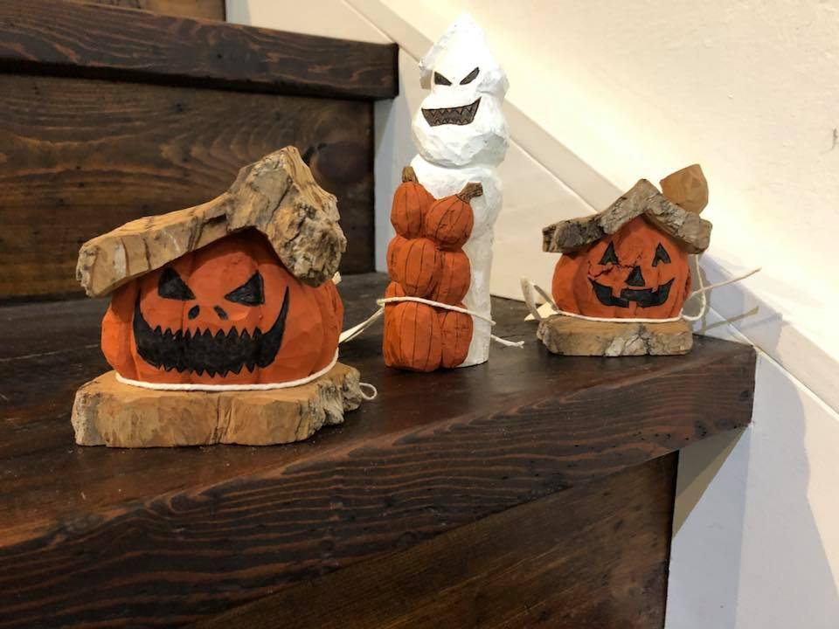
Whimsical Jack-o’-lanterns and Ghost Woodcarving Artist: Lanny
Join this fun adult Halloween carving workshop! In this workshop use your imagination to carve a whimsical jack-o’ lantern, ghost, or a haunted shire house. Celebrate fall and your Halloween spirit in creating this woodcarving from cottonwood bark. Supplies are included. If you have tools and glove from previous workshops, please bring them.
- Sunday, October 20; 1:00 – 4:00 p.m.
- Workshop Fee: $40.00; due at time of registration
- Ages 18 and up
- Class limited to 8

Bling! Bling! And More Bling!! Dichroic Pendants* Artist: Dianne
(A Fused Glass Workshop)
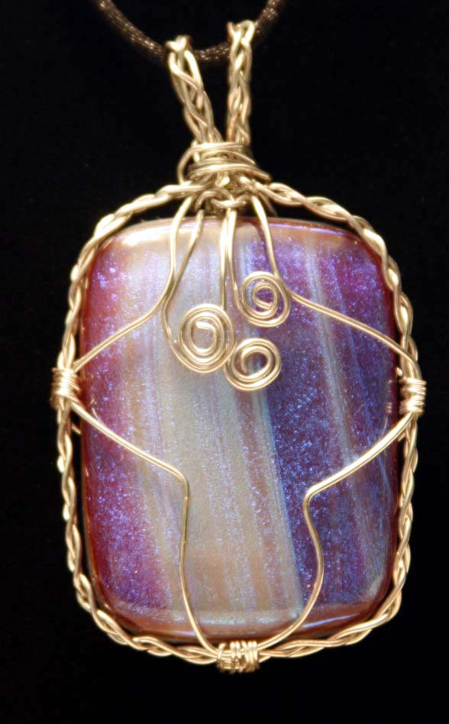
The Holidays are approaching, and you will want to wear your own stunning fused glass dichroic pendant that you make in this workshop. In fact, you will have a choice to wear since you will create 3-4 cabochons in this afternoon workshop. These pendants will make unique Christmas gifts too! Basic glass-cutting skills will be taught, so experience is not necessary. The hardest part of the workshop is deciding which gorgeous glass to use!! Please do not wear open-toed shoes when working with glass. Wire-wrapping is not included in this workshop.

- Saturday, October 26 or Sunday, October 27; 1:00 – 3:30 p.m.
- Workshop Fee: $50.00, due at time of registration
- Ages 14 and up
- Class limited to 10
*Please specify which date you plan to attend upon registering.

Art Exploration! Free! Free! Free!
Are you looking for camaraderie while exploring your artistic side? Join Gallery artist Pat Glick every Tuesday afternoon, 1 p.m. – 3 p.m. to explore different art techniques. Pat will lead you through a creative art experience every week. Feel free to bring something you are working on also. We will have opportunities to participate in community activities and charities at times.
Art Exploration is free so you just bring your willingness to try something new in art!

ArtForms artists also offer pop-up workshops during the month. Follow the Gallery on its Facebook page and/or its website!
- Facebook: https://www.facebook.com/ArtFormsGallery620/
- Website: www.artforms-gallery.com

Do you have a birthday or special occasion to celebrate? Contact the Gallery to book a private party with an ArtForms Gallery artist!
Possibilities include:
- Sip and Paint evening
- Oil or acrylic painting
- Jewelry
- Fused Glass
- Pottery (ceramic birdhouse, windchime, pitchers)
- Textiles and more!

Have a workshop suggestion or special request for us? Don’t hesitate to give us a call!

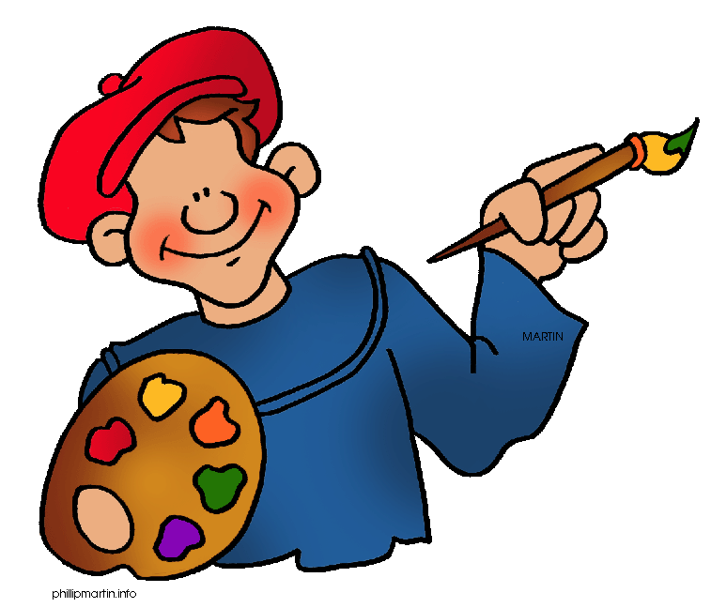
Become a
Gallery Patron
Save 10% on every workshop you take in a 12-month period!!!
Only $40.00

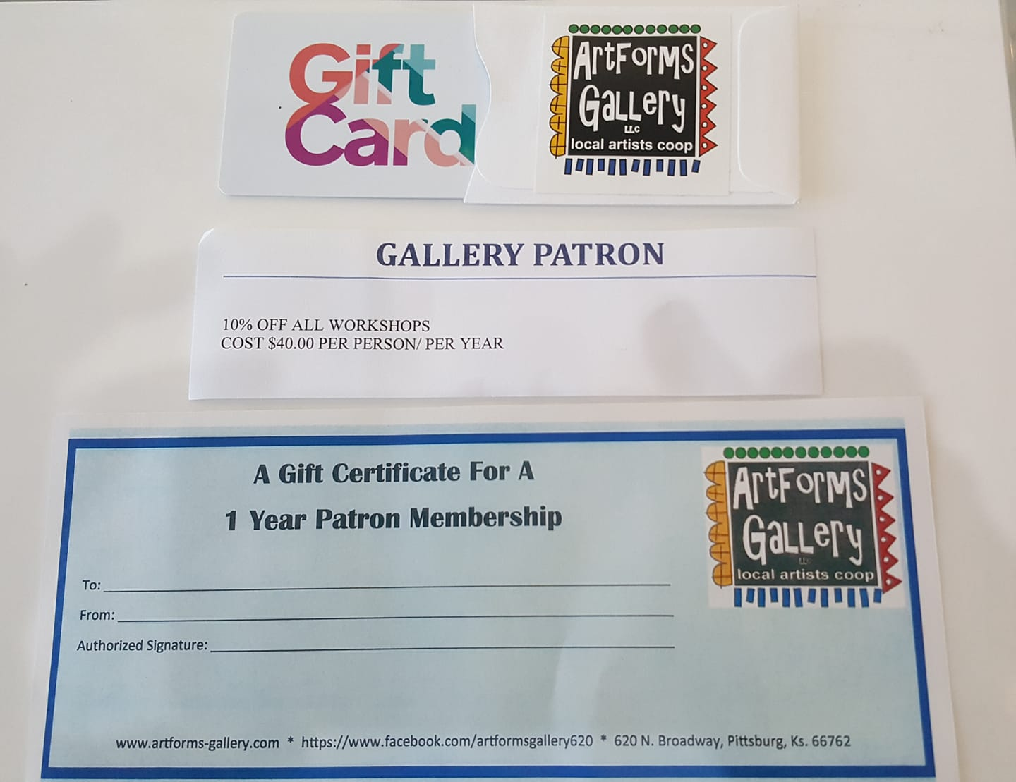

Give the gift of creativity with an
ArtForms Gallery Gift Card or a
Gallery Patron Membership!

